**LESSON 6: MOSFET**

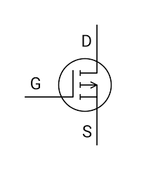

G – GATE

D – DRAIN

S – SOURCE

MOSFET STRUCTURE

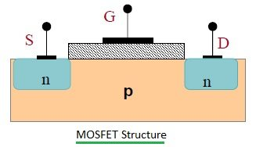

1 **Substrate**:

* Made of **semiconductor material** (commonly silicon).
* Can be either **n-type** or **p-type**, depending on the MOSFET type.

2 **Source (S) and Drain (D)**:

* **Source**: The terminal through which carriers (electrons or holes) enter.
* **Drain**: The terminal through which carriers exit.
* Both are heavily doped regions (n+n^+n+ or p+p^+p+) to ensure good conductivity.

3 **Channel**:

* A thin region between the source and drain in the substrate.
* Conducts current when a voltage is applied to the **gate**.

4 **Gate (G)**:

* A conductive electrode (metal or polysilicon) placed above the substrate.
* Controls the flow of current by modulating the channel.

5 **Oxide Layer**:

* A thin insulating layer (usually silicon dioxide) separates the gate from the channel.
* Prevents direct current flow between the gate and substrate, allowing field-effect control.

6 **Body/Back Gate**:

* The bulk of the substrate, often connected to a fixed potential (e.g., ground).

